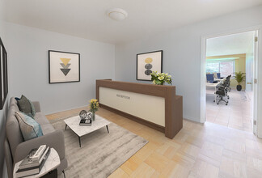

1st Floor, Ste 1D
Size | 1,130 SF
Term | Negotiable
Rental Rate | $50.00 /SF/YR
Space Use | Office
Condition | Partial Build-Out
Available | Now
This apartment is really a professional office. It is in very good condition. It is located in The Whitehall, a luxury full service building, long recognized by real estate influencers as the premier residence in Riverdale, NY. The office is located in the one of the designated professional areas. It is spacious and bright. Because of the layout it can be used by a doctor, dentist, architect, lawyer, designer, accountant and others. The lobby is attended 24 hours. There is a concierge, doorman and cameras throughout. There is also a comfortable seating area. You may use the facilities at a nominal fee, such as the fitness club, gym, garage, year round swimming pool, sundeck and a Green Roof. You are a half block from the bus stop for the MTA and local buses and the Jitney to the Metro North. You are ten minutes from the upper west side.
- Lease rate does not include certain property expenses
- Partially Built Out as Standard Office
- 8’ Finished Ceilings
- Central Air and Heating
- Kitchen
- Wi-Fi Connectivity
- Balcony
- Hard wood floors and a balcony is a plus.

